# AR-CHI-TECH

T.E. mini-project report submitted in partial fulfilment of the requirements of the degree of

### Information Technology

by

**Abhijit Turate (70) [TE IT 1]**

**Priyanka Shinde (71) [TE IT 1]**

**Kesha Mehta (74) [TE IT 1]**

Under the guidance of

**Mrs. Renuka Nagpure**



**Department of Information Technology Atharva College of Engineering, Malad(W)**

**University of Mumbai**

2020–2021

**CERTIFICATE**

This is to certify that the T.E. mini-project entitled **“AR-CHI_TECH”** is a bonafide work of **Abhijit Turate (70) [TE IT 1], Priyanka Shinde (71) [TE IT 1] and Kesha Mehta (74) [TE IT 1]** submitted to University of Mumbai in partial fulfilment of the requirement for the award of the degree of **“Information Technology”** during the academic year 2020–2021.

**Mrs. Renuka Nagpure**

Guide

**Prof. Deepali Maste Dr. S.P. Kallurkar**

Head of Department Principal

# T.E. Mini-Project Report Approval

This mini-project synopsis entitled ***AR-CHI-TECH*** by ***Abhijit Turate, Priyanka Shinde, Kesha Mehta*** is approved for the degree of ***Information Technology*** from ***University of Mumbai***.

**Examiners**

1.

2.

Date:

Place:

III

# Declaration

We declare that this written submission represents our ideas in our own words and where others’ ideas or words have been included, we have adequately cited and referenced the original sources. We also declare that we have adhered to all principles of academic honesty and integrity and have not misrepresented or fabricated or falsified any idea/data/fact/source in our submission. We understand that any violation of the above will be cause for disciplinary action by the Institute and can also evoke penal action from the sources which have thus not been properly cited or from whom proper permission has not been taken when needed.

Signature

Abhijit Turate (70)

Signature

Priyanka Shinde (71)

Signature

Kesha Mehta (74)

Date:

IV

## Abstract

As we know, the first step for building anything is to create a model of the structure of the object to be built. The model acts as the first prototype of the object. A model provides a rough idea about the structure of the actual object and acts as guideline for constructing the object. Architects create a 2D model of a given structure, which is to be built or does already exist. However, 2D models does not provide a detailed view of the actual structure. The common people also find it difficult to interpret and analyze the structure portrayed in 2D model. A 3D model for the given structure would be more understandable and more appealing to the people. Hence, it would be better to create 3D models of the structures. But 3D models require special skill set to create, and takes more time. Thus, a technology to convert the already existing 2D models into 3D view model is required. Thus the idea is to build a 3D model and display it in AR( Augmented Reality) environment.

***Keywords****- AR(Augmented Reality), 2D model, 3D model.*

## Table of Contents

|  |  |  |
| --- | --- | --- |
|  | **Abstract** | V |
|  | **List of Figures** | VII |
|  | **List of Tables** | VII |
| **Chapter 1** | **Introduction** | 1 |
|  | 1.1 Motivation | 2 |
|  | 1.2 Problem Statement | 2 |
|  | 1.3 Objectives | 2 |
|  | 1.4 Scope | 2 |
| **Chapter 2** | **Review of Literature** | 3 |
| **Chapter 3** | **Requirement Analysis** | 4 |
| **Chapter 4** | **Report on Present Investigation** | 5 |
|  | 4.1 Existing System | 5 |
|  | 4.1.1 Block diagram of Existing System | 5 |
|  | 4.2 Implementation | 6 |
|  | 4.2.1 Algorithm/Flowchart | 8 |
|  | 4.2.2 Dataset | 9 |
|  | 4.2.3 Pseudo code | 9 |
|  | 4.2.4 Screenshots of the output with description | 10 |
| **Chapter 5** | **Results and Discussion** | 11 |
| **Chapter 6** | **Conclusion** | 12 |
|  | **References** | 13 |

## List of Figures

|  |  |  |
| --- | --- | --- |
| **Figure No.** | **Figure Name** | **Page No.** |
| 4.1 | Block diagram of existing system. | 5 |
| 4.2 | Setting target image. | 6 |
| 4.3 | 3D model displayed on top of target image. | 7 |
| 4.4 | Flowchart | 8 |
| 4.5 | Target image. | 9 |
| 4.6 | Side view. | 10 |
| 4.7 | Top view. | 10 |
| 5.1 | Dynamic model deployed in AR in unity | 11 |
| 5.2 | Outputs | 11 |

**List of Tables**

|  |  |  |
| --- | --- | --- |
| **Table No.** | **Table Name** | **Page No.** |
| 1 | Literature Survey | 3 |

**Chapter 1**

**Introduction**

Augmented reality is the integration of digital information with the user's environment in real time. Unlike virtual reality, which creates a totally artificial environment, augmented reality uses the existing environment and overlays new information on top of it. Today, Google glass and heads-up displays in car windshields are perhaps the most well-known consumer AR products, but the technology is used in many industries including healthcare, public safety, gas and oil, tourism and marketing. AR is a very famous and rapidly growing field. It is used almost all the fields for better understanding of a concept.

AR-CHI-TECH is such an app that helps common people understand the 2D floor plans drawn by architects by creating a 3D model of that given plan just by scanning it. Understanding 3D models is way easier than understanding 2D floor plans drawn by an architect using some notations.

The application is capable of creating a 3D model of a given 2D plan. It first scans the given plan and then builds a corresponding 3D model by replacing the lines forming the rooms with actual walls. This process requires a 3D game engine to build the application; which in this case is Unity.

**1.1 Motivation**

The floor plans that an architect designs are quite difficult for the common people to understand because it includes technical terms, symbols, markings which makes it hard for them to understand and visualize the final results.

Our aim is to display floor plan models in an Augmented Reality environment to help the common people to understand and visualize how the construction would actually look after completion**.**

**1.2 Problem Statement**

It has been observed that the floor plans an architect designs are complicated for common people to understand. The floor plan drawings consist large number of technical symbols and markings which are not understood by non-technical people. Also it is difficult to visualize a 3D finished result from a 2D drawing. Our system will display models in an augmented reality environment to help user to visualize the end results.

**1.3 Objective**

The objectives are as follows-

* To make an efficient, hassle free and user friendly system.
* To provide clear vision of end results to users.
* To make cost effective system.
* To save time and cost of architect.

**1.4 Scope**

This application will provide a sense of aesthetic and a realistic scene of floor plans in the augmented reality environment for the user’s experience with the system. app that helps common people understand the 2D floor plans drawn by architects by creating a 3D model of that given plan just by scanning it. Understanding 3D models is way easier than understanding 2D floor plans drawn by an architect using some notations.This will be useful for construction related work. In future the user can generate a 3D model for not only floor plans but also, for other images he wishes to view in 3D. The user can later save the model as an .fbx file which can be used later for printing from a 3D printer.

**Chapter 2**

**REVIEW OF LITERATURE.**

|  |  |  |  |
| --- | --- | --- | --- |
| **Sr.No** | **Title** | **Author** | **Description** |
| **1.** | Dynamic 3D Model Construction using Architectural House Plans | R.G.N Ruwanthika  P.A.D.B.M Amarasekera  R.U.I.B Chandrasiri  D.M.A.I Rangana,IEEE(2017) | The paper presents a complete approach to a dynamic 3D Model construction from 2D House plans. |
| **2.** | Parsing Floor Plan Images | Samuel Dodge, Jiu Xu, Björn Stenger.  IEEE (2017). | This paper introduces a method for analyzing floor plan images using wall segmentation, object detection, and optical character recognition. |
| **3.** | Raster-to-Vector: Revisiting Floorplan Transformation | Chen Liu, Jiajun Wu, Pushmeet Kohli, Yasutaka Furukawa. IEEE(2017). | This paper addresses the problem of converting a rasterized floorplan image into a vector- graphics representation |
| **4.** | Using Unity 3D to facilitate mobile augmented reality game development | Sung Lae Kim; Hae Jung Suk; Jeong Hwa Kang; Jun Mo Jung; Teemu H. Laine; Joonas Westlin.  IEEE(2016) | Mobile augmented reality (mobile AR) enables virtual content such as 3D models, animations and annotations to be placed on top of a real world objects in any context. |

Table no.1- Literature Survey

**Chapter 3**

**REQUIREMENT ANALYSIS.**

* **Software requirements**
* Vuforia Support
* Android KitKat (4.4 or greater)
* **Hardware Requirements**
* Qualcomm Snapdragon 450 or above
* 2 GB ram
* Minimum disk space: 50 MB
* Rear Camera of a good quality

**Chapter 4**

**REPORT ON PRESENT INVESTIGATION.**

**4.1 Existing system.**

All the existing papers talk about just creating a 3D model of the drawing. Our aim is to display this model in an Augmented Reality environment to help the user visualize how the construction would actually look after completion. Also no research papers regarding this topic were published since 2017, so we also plan on using the latest available technologies to create a more efficient system.

One of the system that exists is ‘Dynamic 3D model construction using architectural house plans’ which is a complete approach to a dynamic 3D model construction from 2D house plans.It covers 3 dimensions i.e wall detection, wall modeling, roof detection, roof modeling and template matching of doors/windows.

**4.1.1 Block diagram of existing system.**

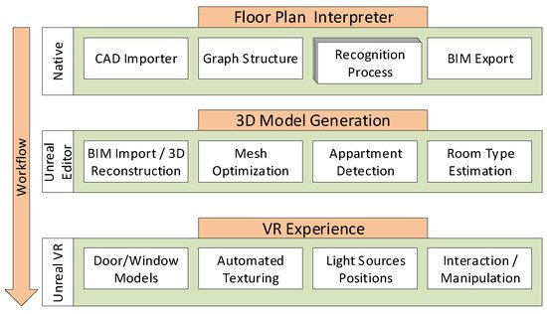

Fig 4.1: Block diagram of existing system.

**4.2 Implementation.**

With all the Hardware and Software Requirements being known to us, we possessed all of the above given requirements and, downloaded and installed all the SDK’s and Softwares required. After acquiring all the assets, we developed a test application as a way of figuring out how can these technologies sync together and work cohesively for accomplishment of a single task.In this case study, we first converted the 2D floorplan image of JPEG format into SVG file. Then we used Blender software to scale the height of the SVG image and made a 3D model of the image. Then we took an image (“FC Barcelona logo”) and used it as a target image, upon which our 3D model created will be displayed in AR. We stored our target image in the Vuforia database. Vuforia generates a license key for every database created by the user. This license key is used by Unity, to retrieve the target images from specified database.We made use of Vuforia plugin for Unity, which enables the use of a unique Component called AR Camera, which accesses the web cam of the PC and helps in Target image detection.

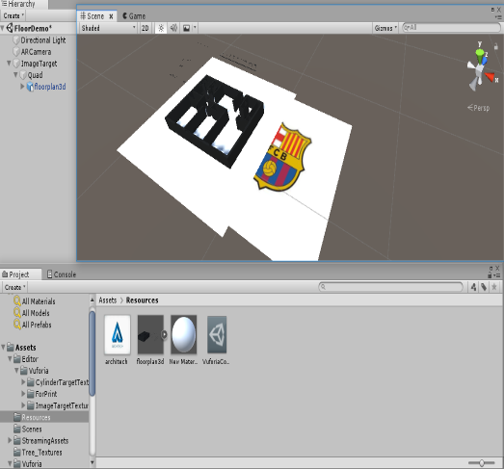

Fig 4.2: Setting target image

Upon detecting the Target image specified in the Vuforia database, the 3D model created with the help of blender got displayed on top of the Target image.

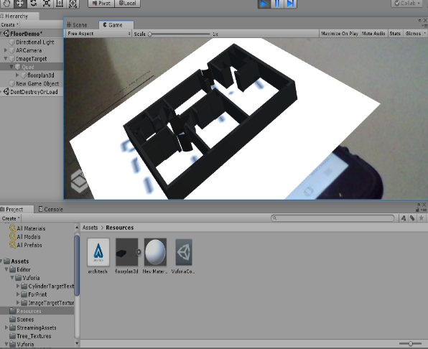

Fig 4.3**-** 3D model displayed on top of the Target image

**4.2.1 Flowchart**

Fig 4.4 Flowchar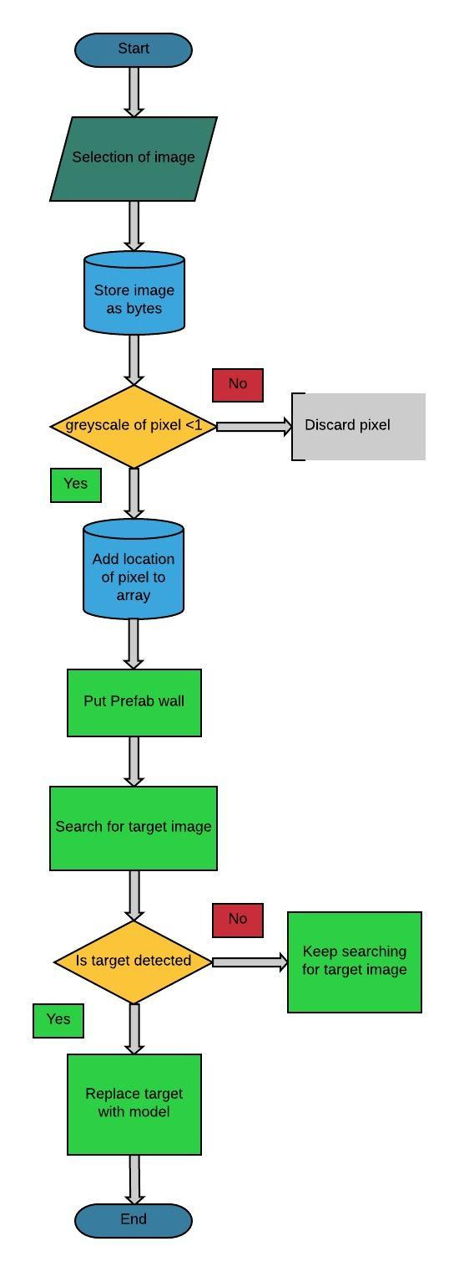t

**4.2.2 Dataset.**

Following is the target image used-



Fig 4.5: Target image.

**4.2.3 Pseudo code**

* Selection of image.
* Store image as bytes.
* Detection of greyscale of pixel.
* Add location of pixel to array.
* Put prelab wall.
* Detect target image.
* Replace target with model.

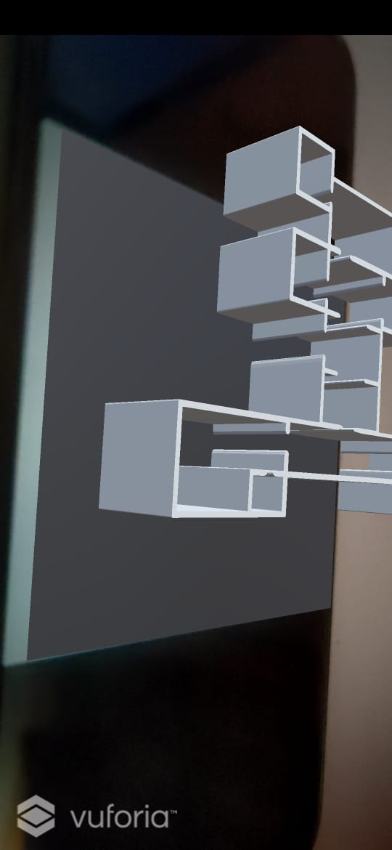**4.2.4 Screenshots of the output with description.**

Fig 4.6: Side view

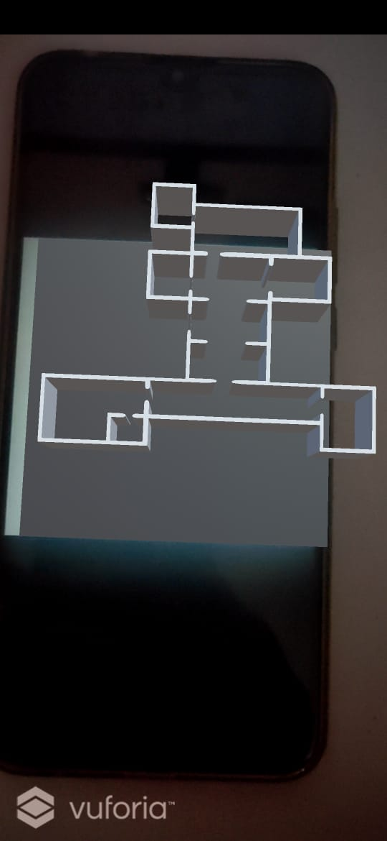

Fig 4.7: Top view

**Chapter 5**

**RESULTS AND DISCUSSION.**

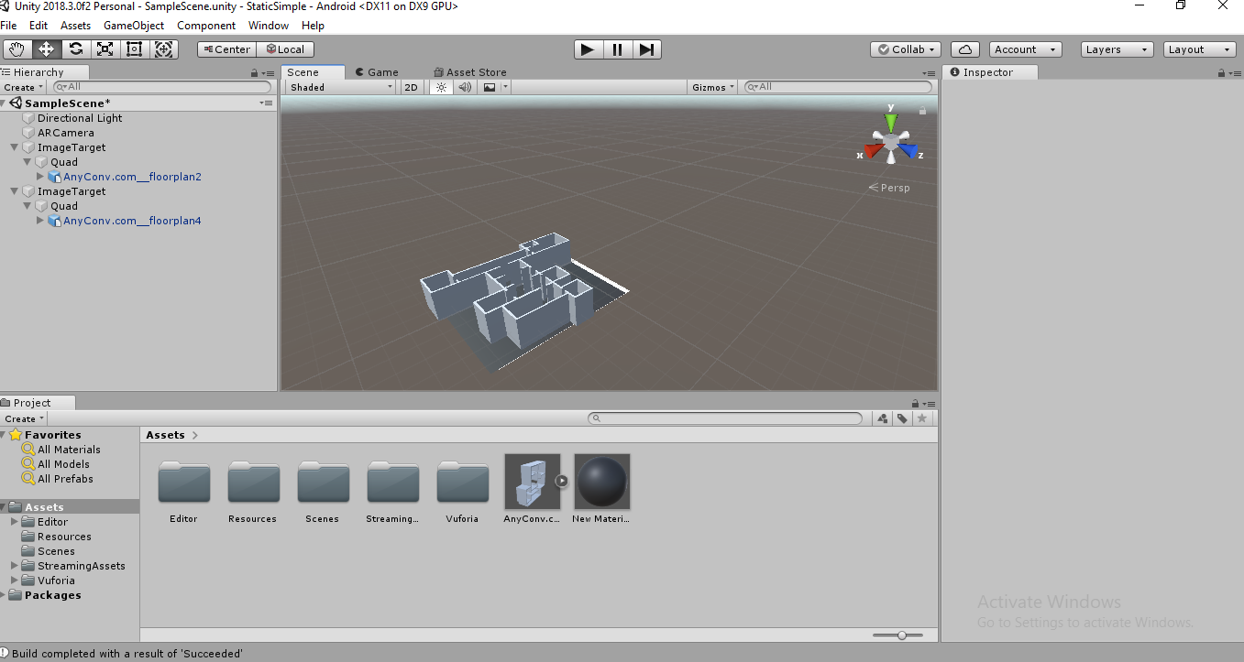

Fig 5.1: Dynamic Model Displayed in AR in Unity

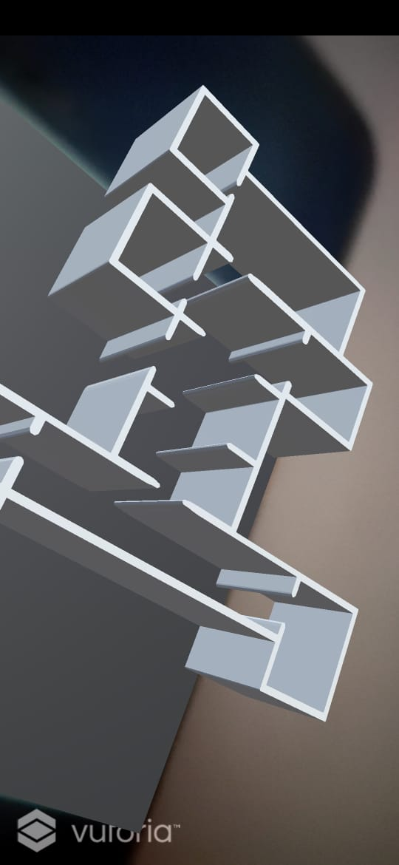Fig 5.2: Output

**Chapter 6**

**CONCLUSION**

In this project, we demonstrated some conclusive results on our 3-phase recognition approach to pseudo 3D building generation from 2D floor plan. The 3D Generation module provides a sense of aesthetic and a realistic scene in the 3D environment for the user’s experience with the system. It provides interactive and navigational capabilities with different views. We used existing image processing techniques like convert image into texture2d format & process each pixel, calculate greyscale of each pixel and use that greyscale value to instantiate wall.

**REFERENCES**

1] Ruwanthika, R. G. N., et al. "Dynamic 3D model construction using architectural house plans." *2017 6th National Conference on Technology and Management (NCTM)*. IEEE, 2017.

2] Dodge, Samuel, Jiu Xu, and Björn Stenger. "Parsing floor plan images." *2017 Fifteenth IAPR international conference on machine vision applications (MVA)*. IEEE, 2017.

3] Liu, Chen, et al. "Raster-to-vector: Revisiting floorplan transformation." *Proceedings of the IEEE International Conference on Computer Vision*. 2017.

4] Kim, Sung Lae, et al. "Using Unity 3D to facilitate mobile augmented reality game development." *2014 IEEE World Forum on Internet of Things (WF-IoT)*. IEEE, 2016.

5] Moro, Christian, et al. "HoloLens and mobile augmented reality in medical and health science education: A randomised controlled trial." *British Journal of Educational Technology* 52.2 (2021): 680-694.